|  |  |
| --- | --- |
|  | FPT ACADEMY INTERNATIONAL  FPT – APTECH COMPUTER EDUCATION |

Centre Name: ACE-HCMC-2-FPT.

Address: 590 Cach Mang Thang 8, District 3, Ho Chi Minh City, Viet Nam.

**[Historical Monument]**

|  |  |  |
| --- | --- | --- |
| Supervisor: | Phạm Thị Lánh | |
| Term: | T1.2203.M1 | |
| Batch No: | 1 | |
| Group No: | 1 | |
| Order: | Full name | Roll No. |
| 1. | Lê Minh Thắng | Student1373759 |
| 2. | Tẩy Cẩm Liên Vinh | Student1373767 |
| 3. | Nguyễn Quí | Student1373753 |
| 4. | Đặng Nguyễn Trung Kiên | Student1373761 |

Month 04 Year 2022

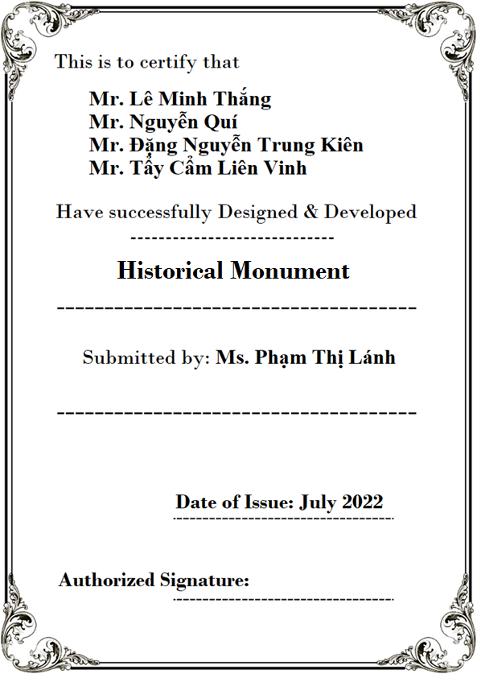

# Content

[Content 3](#_Toc102552487)

[Acknowledge 5](#_Toc102552488)

[Synopsis 6](#_Toc102552489)

[Review 1 7](#_Toc102552490)

[Problem Definition 8](#_Toc102552491)

[Customer Requirements Specifications 9](#_Toc102552492)

[Architecture and Design of the project 10](#_Toc102552493)

[Site map 11](#_Toc102552494)

[Screen shots 12](#_Toc102552495)

[I.Homepage 12](#_Toc102552496)

[II.Seven Wonders 14](#_Toc102552497)

[III.Gallery 1](#_Gallery)7

[IV.About Us 1](#_About Us)8

[V.Contact Us 1](#_Contact us)9

[Task Sheet 25](#_Toc102552507)

[Review 2 26](#_Toc102552508)

[I.Homepage 23](#_Homepage_1)

[II.Seven Wonder 25](#_Seven wonder world_1)

[III.Gallery 3](#_Gallery_1)0

[IV.About Us 31](#_About Us)**[.](#_About Us)**

[V.Contact Us](#_Contact Us) **[Error! Bookmark not defined.](#_Contact Us)**

[Task Sheet 40](#_Toc102552520)

[Testing document 41](#_Toc102552521)

[Final checklist 42](#_Toc102552522)

# Acknowledge

As we understand that the eProject is a step-by-step learning environment that closely simulates the classroom and Lab based learning environment into actual implementation. It is a project implementation at your fingertips!! An electronic, live juncture on the machine that allows you to.

* Practice step by step i.e., laddered approach.
* Build a larger, more robust application.
* Usage of certain utilities in applications designed by the user.
* Single program to unified code leading to a complete application.
* Learn implementation of concepts in a phased manner.
* Enhance skills and add value.
* Work on real life projects.
* Give a real-life scenario and help to create applications more complicated and useful.
* Mentoring through email support.

We would like to send a great thank to our professor and others student for the adorable support during the time in the project.

Beside several mistakes we had made in the project, we hope to have more opportunities to widen our knowledge in the web developing world.

We also thank you so much for your information and the “demo” project from India APTECH to help us get more reality experience in this project. Since we have gained more experience from this project, we will not stop learning anything as much as we can to be more successful in the future.

Your Sincerely,

Team Group 01.

# Synopsis

* The Objective of this program we aim is to give a sample project to work on real life projects. These applications help us build a larger, more robust application.
* The objective is not to teach us HTML/JavaScript but to provide us with a real-life scenario and help us create basic applications using the tools.
* Hence, we can revise the chapters before we start with the project.
* This project The Objective of this program is to give a sample project to work on real life projects. These applications help you build a larger, more robust application.
* The objective is not to teach you the software but to provide you with a real-life scenario and help you create basic applications using the tools.
* You can revise the topics before you start with the project.
* This project is meant for students who have completed the module of HTML5.
* These programs should be done in the Lab sessions with assistance of the faculty if required.
* The website (in this project) is a tool that help the company to access the international market and gain more and more new customers.
* It is very essential that a student has a clear understanding of the subject.

# REVIEW 1

## Problem Definition

Historical Monument website will present the information about the various historic places throughout the world. The information behind this creature must be added. The information of historic places can be categorized based on zone wise (NORTH, SOUTH, WEST and EAST). The link of seven wonders, Gallery section, Contact Us, Feedback and Site Map must be added.

The website is to be developed for the Windows Platform using HTML5, JavaScript and Geolocation. The site should work well in all leading browsers including Chrome, IE, Firefox etc.

**Requirement Specification:**

The Web site is to be created based on the following requirements.

1. The Home Page should be created making use of Sections with a suitable logo, the header section can be added which will show different famous images of monuments.
2. The site must contain the links to navigate through any zone for the information.
3. Links of monuments can be categorized by zone wise like (East, North, West and South) apart from world wonders link can be added.
4. History behind all the monuments can be added along with the images.
5. Gallery section can be added for viewing different images.
6. Feedback must be allowed to enter by the viewer
7. Site map, Gallery, about us, Queries link, Contact us link must be added.
8. The “Contact Us” page should have the Address of the Company and the mail address which when clicked will invoke the local mail client from where they can send an email. Address of the Company should be displayed using GeoLocation API (eg. GoogleMaps).
9. The complete historic reason and its description must be allowed to get download as pdf or doc file.

The advertise section of bus, flights can be included for reaching the places.

## Customer Requirements Specifications

|  |
| --- |
| USER: |
| Input:   * Send questions/feedback to the company |
| Process:   * Collect questions/feedback sent by consumers |
| Output:   * Reply to the consumer’s feedback/questions |

|  |
| --- |
| WEBMASTER: |
| Input:   * Control website database |
| Process:   * Analyse website |
| Output:   * Website interface, images, feedback, … * Giving interaction |

|  |
| --- |
| HARDWARE / SOFTWARE REQUIREMENT: |
| Software:   * Notepad/HTML editor * Dreamweaver/Javascript * IE 5.0/ Netscape 6.0 |
| Hardware:   * A minimum computer system that will help you access all the tools in the courses is a Pentium 166 or better * 64 Megabytes of RAM or better |

## Architecture and Design of the project



## Site map

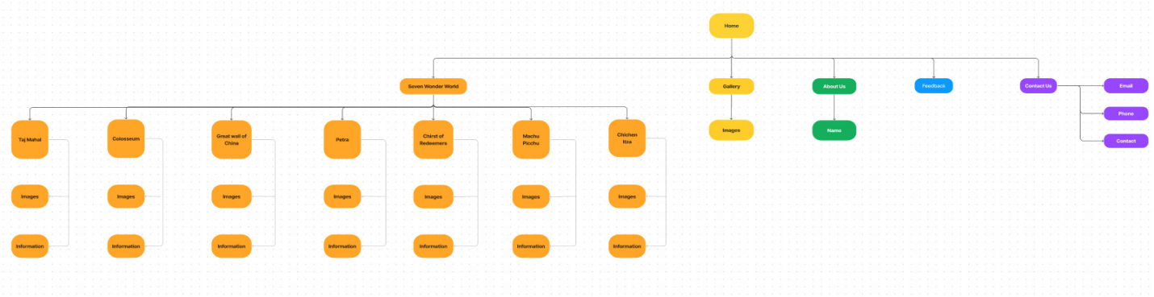

## Screen shots

### Homepage

**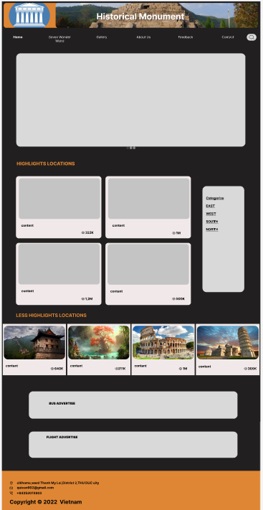**

**Description**:

This is the homepage of Historical Monument, which consists of 4 sections: the header, then the navigation bar, the HIGHLIGHTS LOCATION and the footer

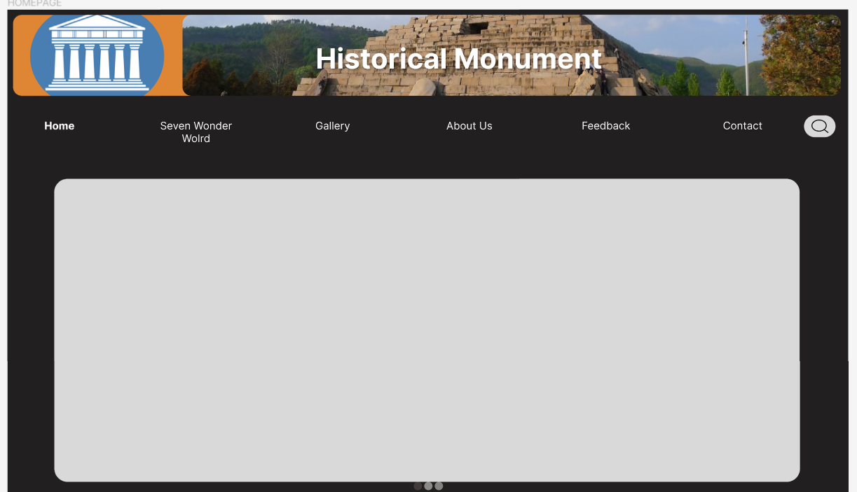

At the top of this page is the website's title, followed by the navigation bar. Below are photo slides of some typical places.

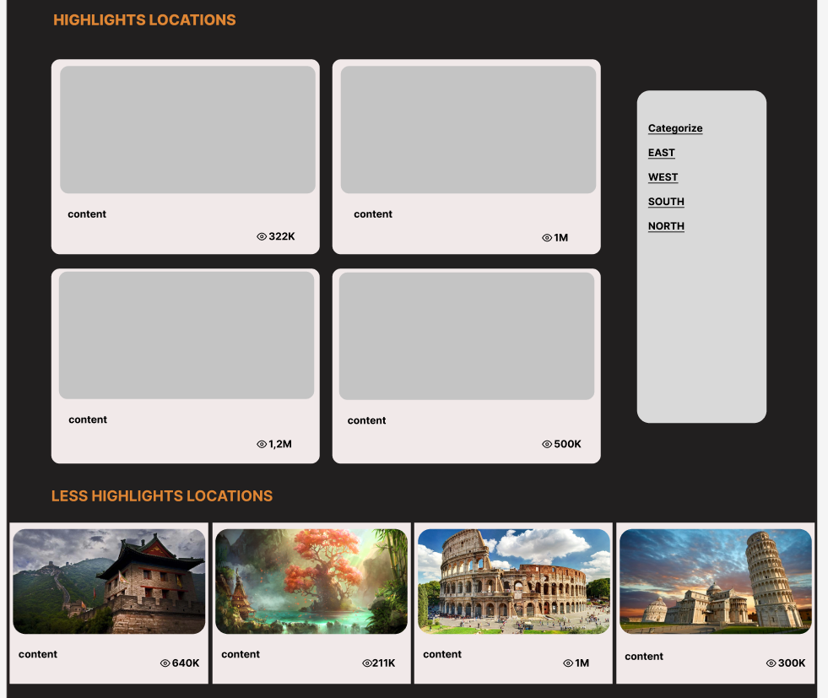

Highlights Locations is an image of prominent places, when clicking on the image will lead to a website introducing that place.



The bottom will contain ads, the footer is contact information.

### Seven wonder world

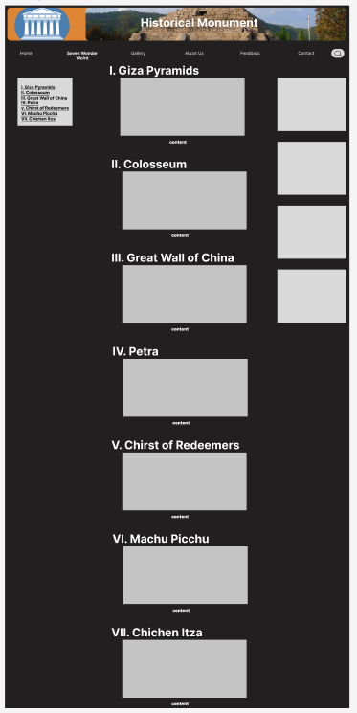

**Description:**

Talk about the seven wonders of the new world; When the reader clicks to select each wonder, there will be a detailed article

**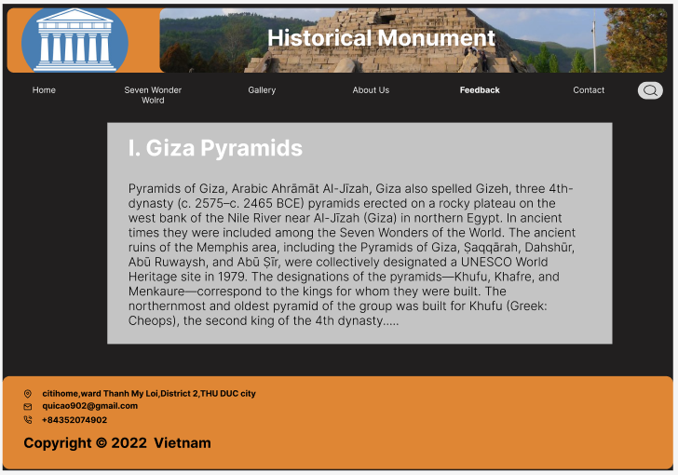**

Detailed articles will be displayed when clicking "see more"

### [Galler](#_Gallery)**[y](#_Gallery)**

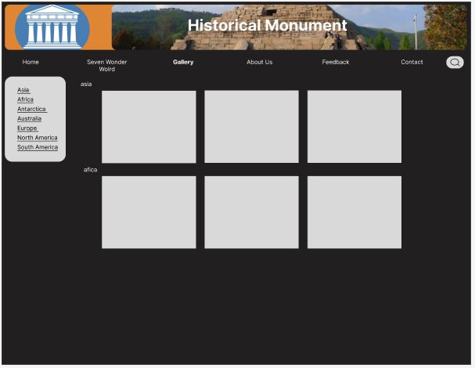

**Description:**

The gallery will contain pictures of wonders and other beautiful places. These wonders will be divided by continent.

### About us

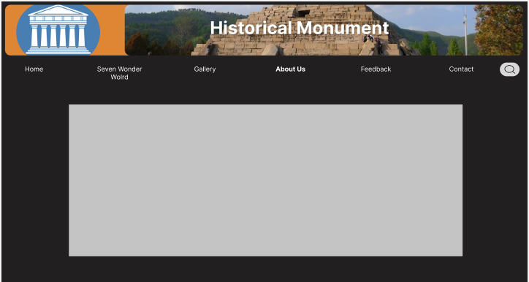

**Description:** This is the website's introduction page.

### Feedback

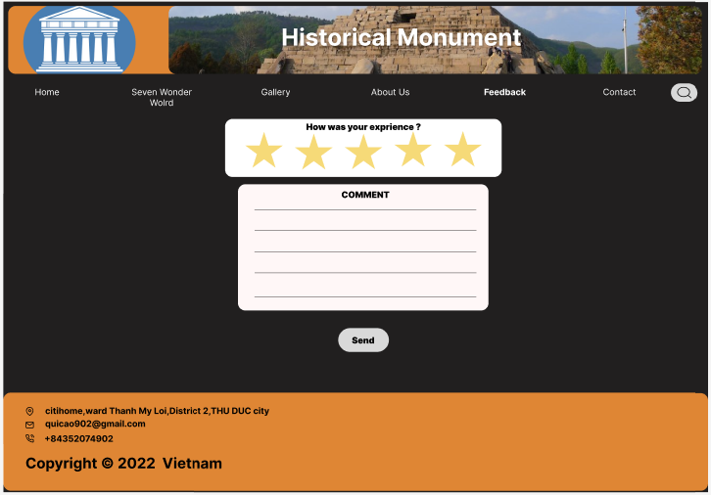

**Description:** After reading the articles on the website, readers can give their reviews, comments and suggestions here.

### Contact us

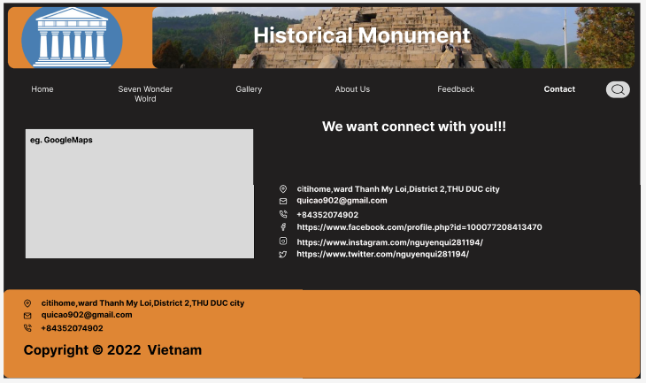

**Description:** where the contact form of the site is located.

## Task Sheet

|  |  |  |  |  |  |  |
| --- | --- | --- | --- | --- | --- | --- |
| **Project Ref No.** | **Project Title – Ask Me Mobile** | **Activity Plan Prepared by** | **Date of preparation of Activity Plan** | | | |
| **Task** | **Actual Start Date** | **Actual Days** | **Teammate Names** | **Status** |
| Brainstorming ideas for layouts and Project Object | | Nam, Sơn, Anh | 30/03/2022 | 1 days | Nam, Sơn, Anh | Completed |
| Draw site maps and architecture design | | Nam, Sơn, Anh | 30/03/2022 | 1 days | Nam, Sơn, Anh | Completed |
| Wire framing general page layout | | Anh | 02/04/2022 | 3 days | Anh | Completed |
| Collect static assets (pictures, mp4, documentation,…) | | Nam, Sơn | 02/04/2022 | 5 days | Nam, Sơn | Completed |

# 

# REVIEW 2

# WEBSITE USER INTERFACE

### Homepage

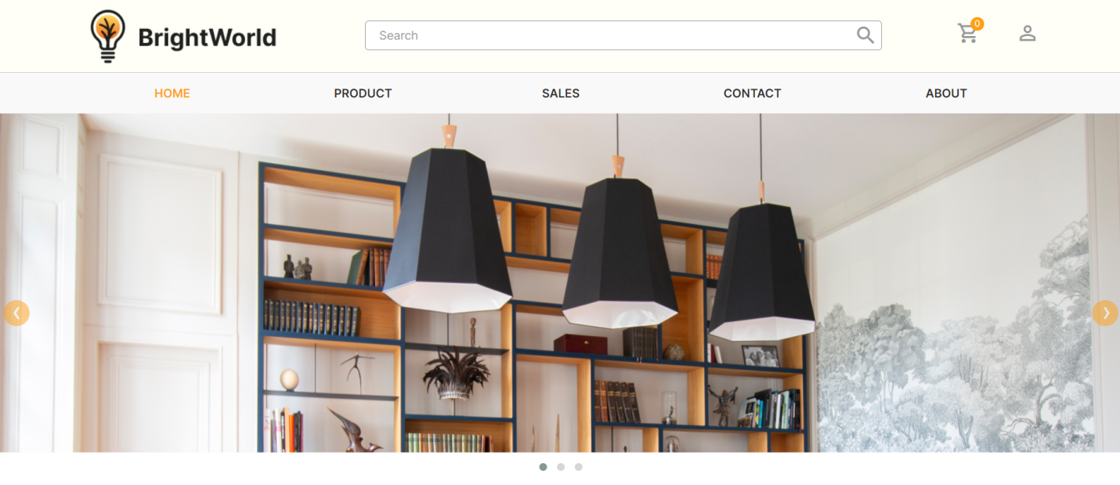

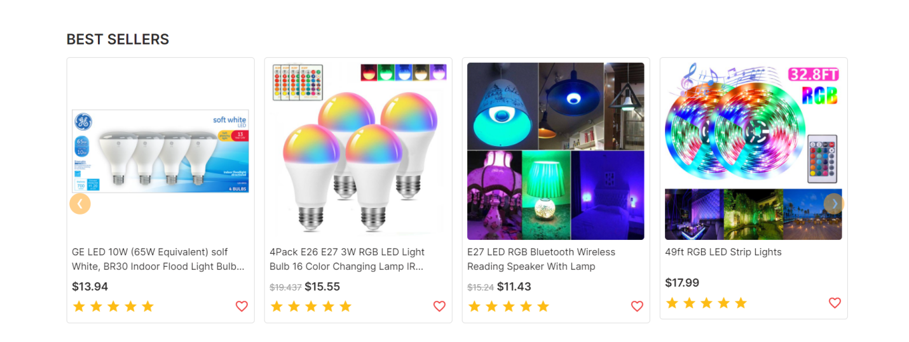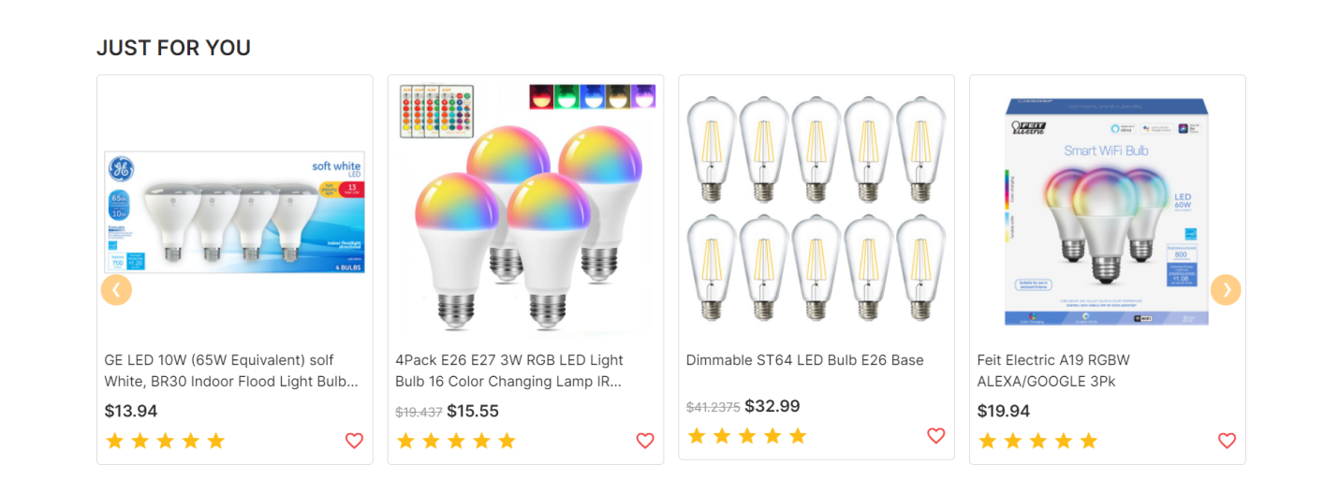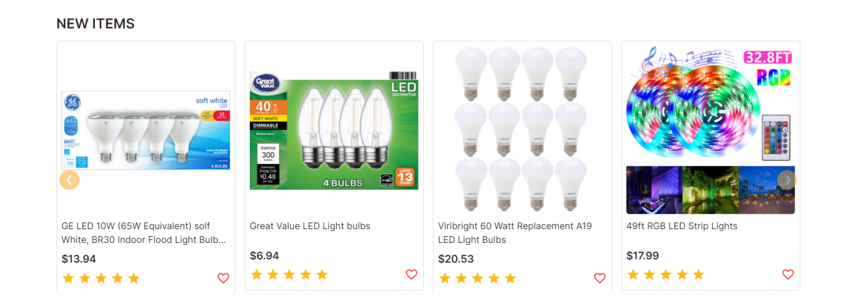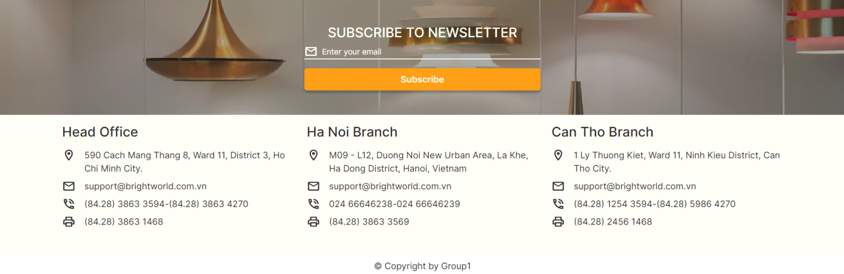

### Seven wonder world

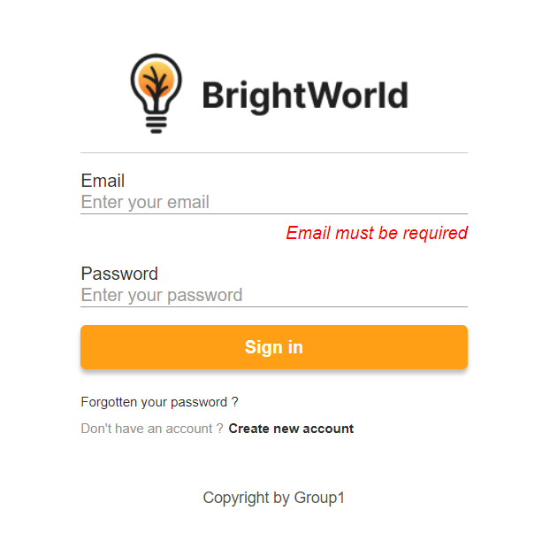

### Gallery

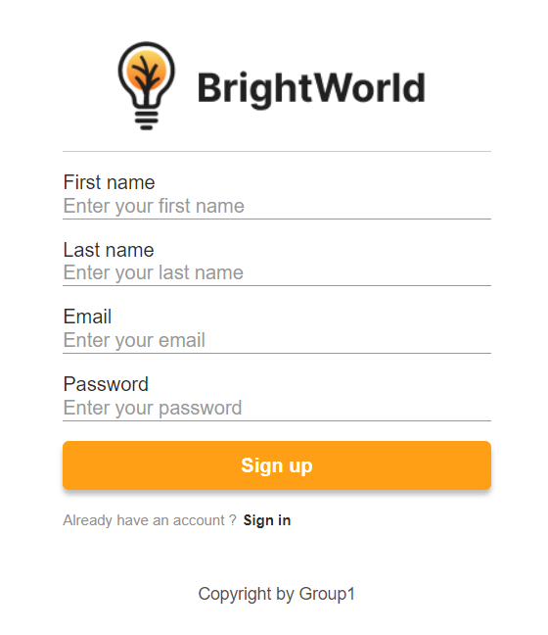

### About Us

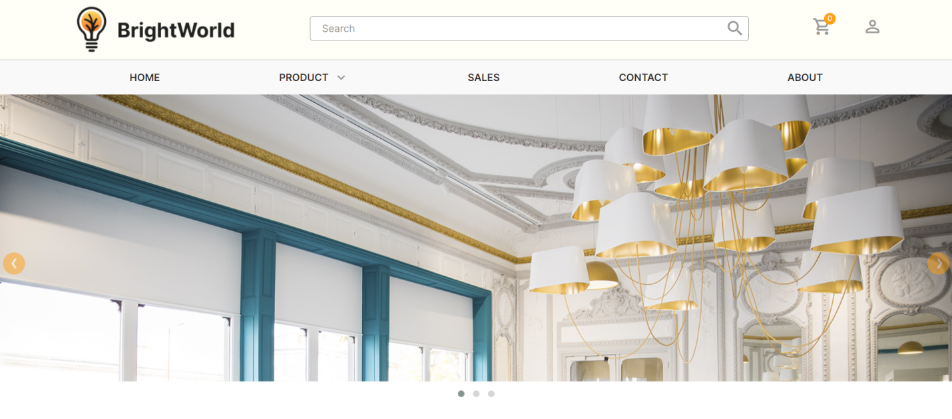

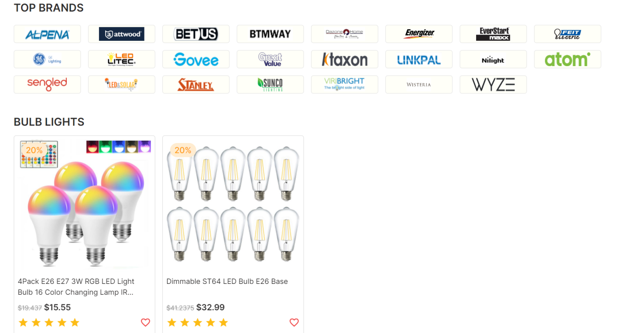

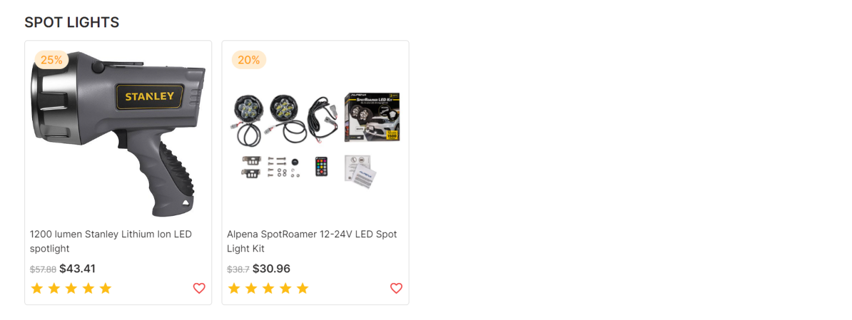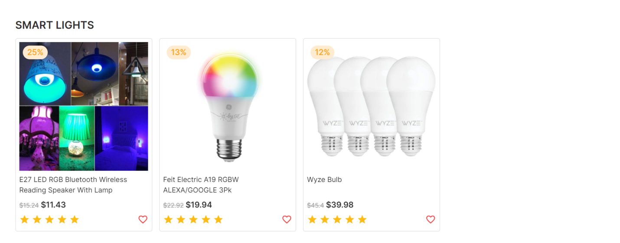



### Feedback

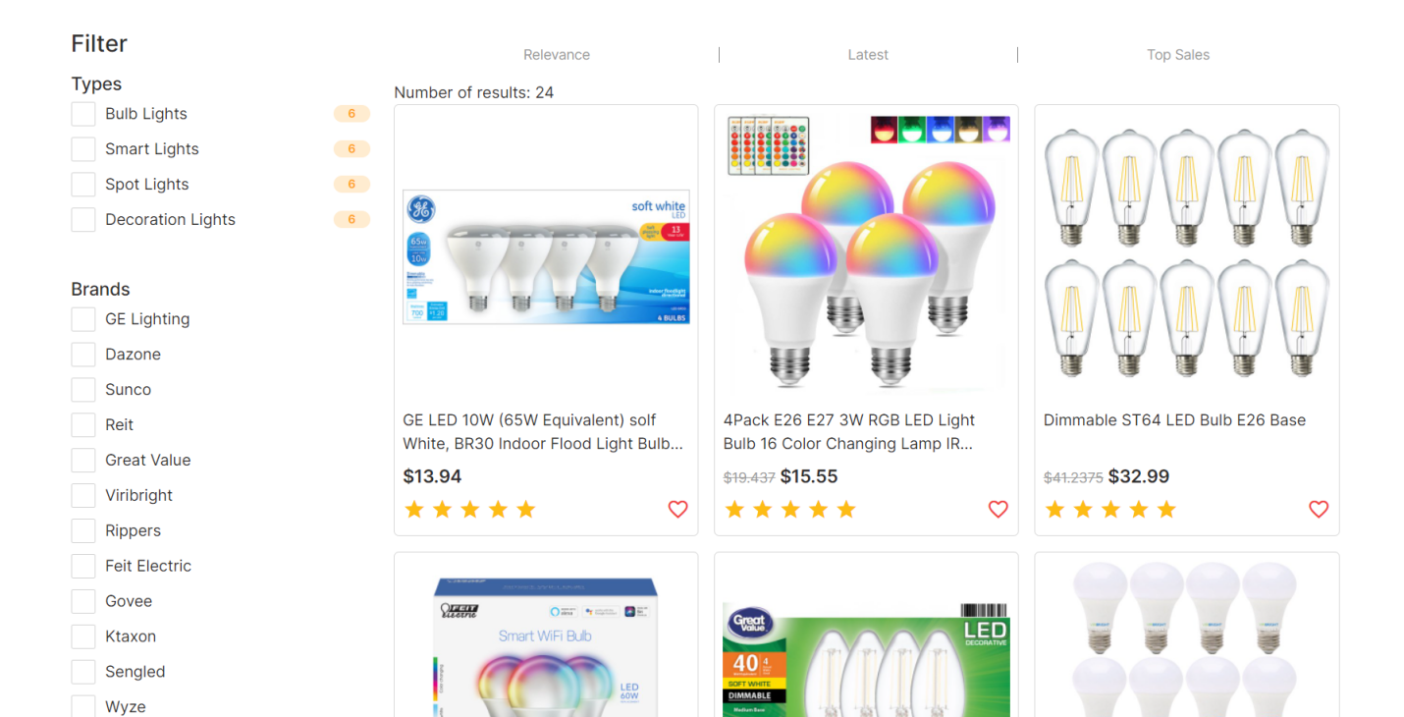

### Contact Us

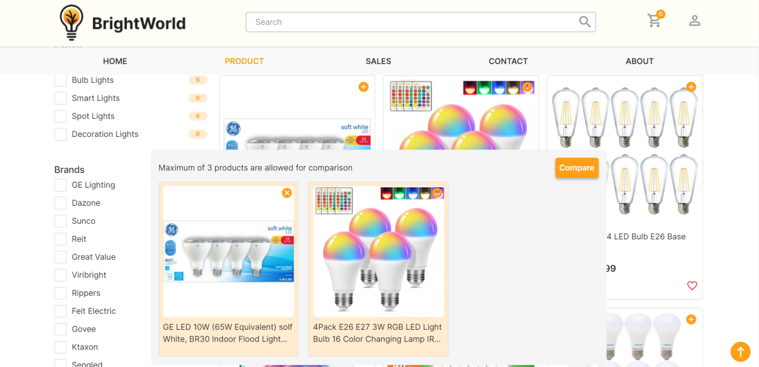

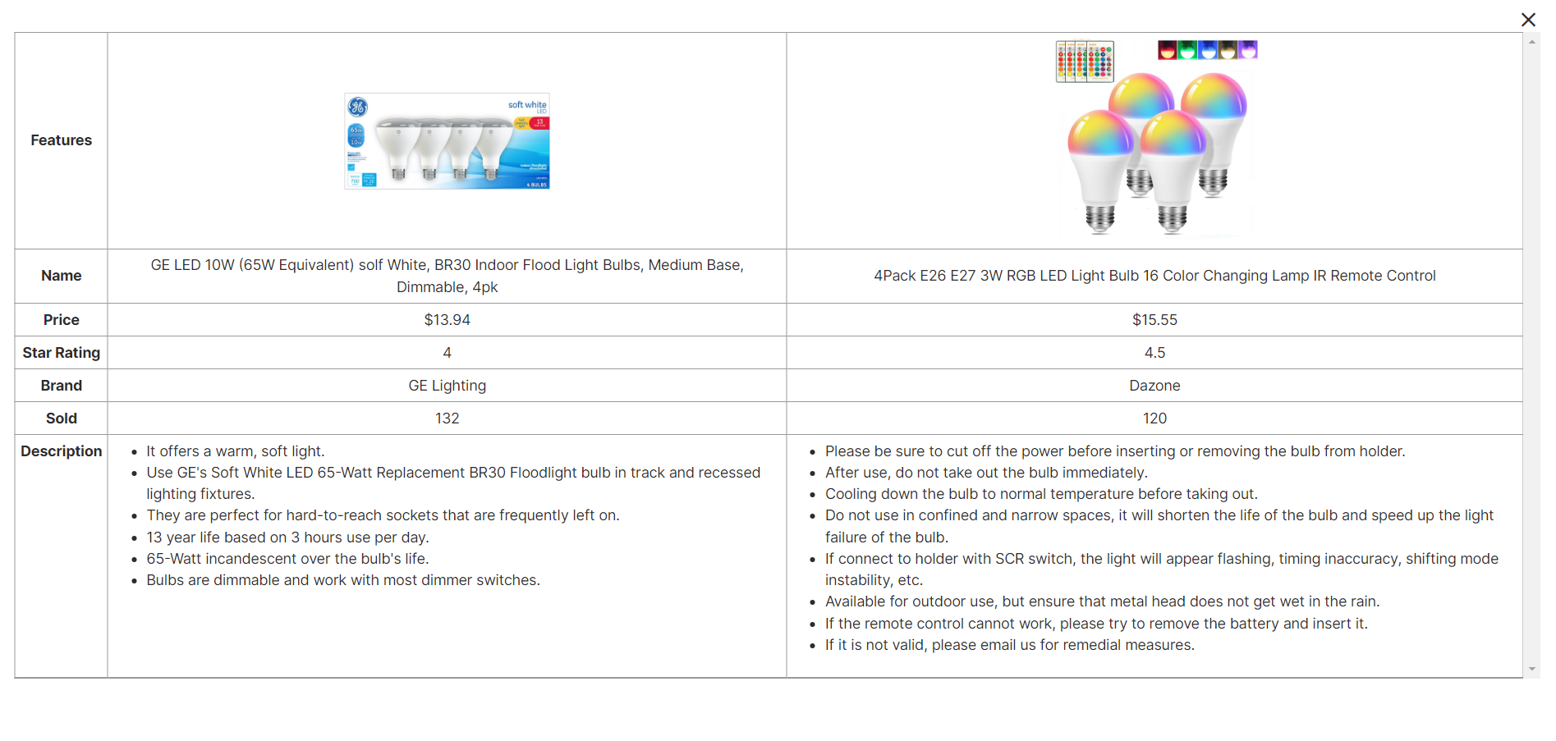

### Contact

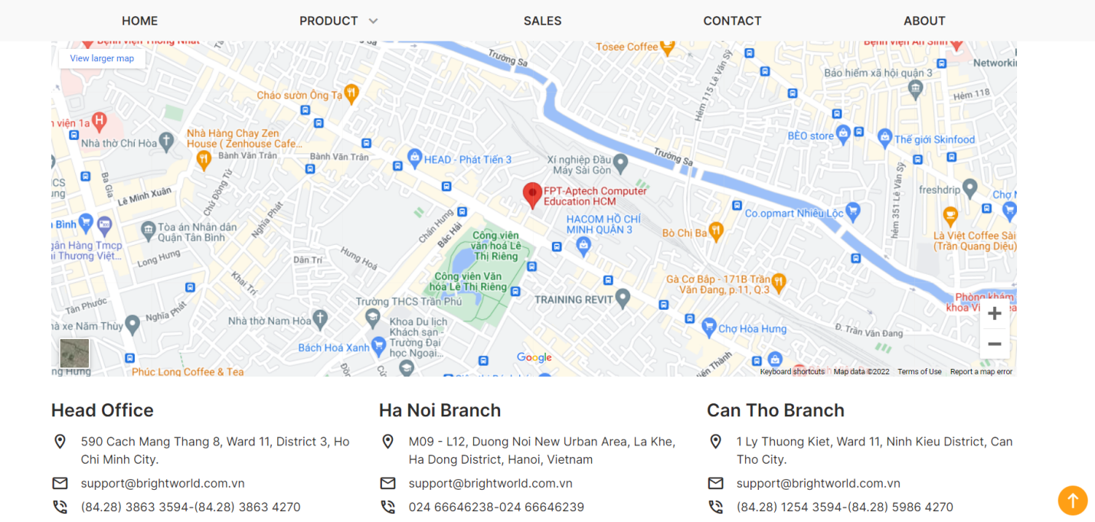

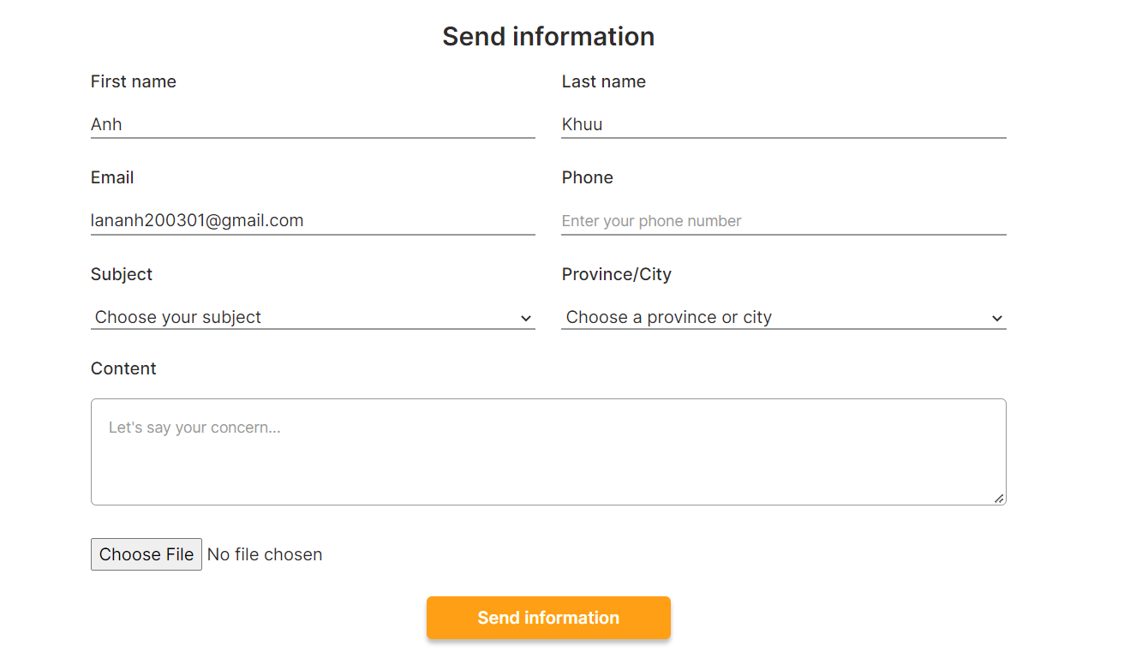

### About

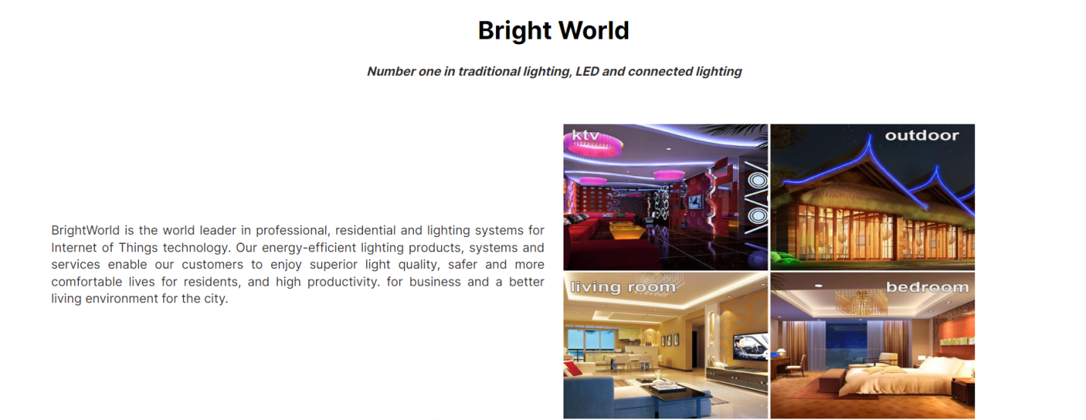

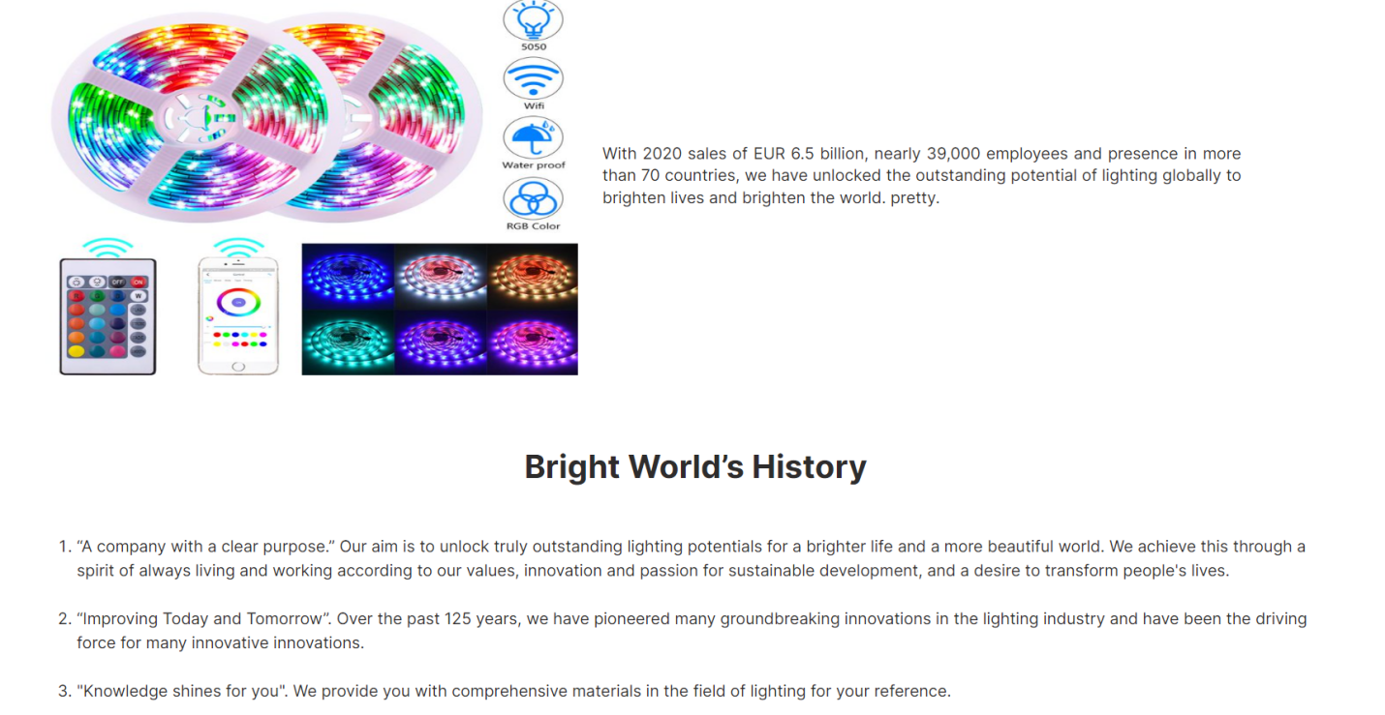

## Task Sheet

|  |  |  |  |  |  |  |
| --- | --- | --- | --- | --- | --- | --- |
| **Project Ref No.** | **Project Title – Ask Me Mobile** | **Activity Plan Prepared by** | **Date of preparation of Activity Plan** | | | |
| **Task** | **Actual Start Date** | **Actual Days** | **Teammate Names** | **Status** |
| Brainstorming ideas for layouts and Project Object | | Nam, Sơn, Anh | 30/03/2022 | 1 days | Nam, Sơn, Anh | Completed |
| Draw site maps and architecture design | | Nam, Sơn, Anh | 30/03/2022 | 1 days | Nam, Sơn, Anh | Completed |
| Wire framing general page layout | | Anh | 02/04/2022 | 3 days | Anh | Completed |
| Collect static assets (pictures, mp4, documentation,…) | | Nam, Sơn | 02/04/2022 | 5 days | Nam, Sơn | Completed |
| Design & Build Homepage | | Anh | 06/04/2022 | 8 days | Anh | Completed |
| Design & Build Sign in | | Nam | 06/04/2022 | 5 days | Nam | Completed |
| Design & Build Sign up | | Nam | 06/04/2022 | 5 days | Nam | Completed |
| Design & Build Sales | | Anh | 10/04/2022 | 3 days | Anh | Completed |
| Design & Build Product Category/Search Page | | Anh | 12/04/2022 | 5 days | Anh | Completed |
| Design & Build Product Detail | | Anh | 15/04/2022 | 4 days | Anh | Completed |
| Design & Build Cart Dropdown | | Anh | 17/04/2022 | 2 days | Anh | Completed |
| Design & Build Check out | | Sơn | 06/04/2022 | 5 days | Sơn | Completed |
| Design & Build Contact | | Sơn | 10/04/2022 | 5 days | Sơn | Completed |
| Design & Build About | | Nam | 10/04/2022 | 3 days | Nam | Completed |
| Product Comparison | | Anh | 04/04/2022 | 1 days | Anh | Completed |
| Write Project Report | | Sơn, Anh | 19/04/2022 | 1 days | Sơn, Anh | Completed |

## Testing document

|  |  |  |  |  |
| --- | --- | --- | --- | --- |
| **Sr.No** | **Features Tested** | | | **Remarks** |
| 1 | Are all the users able to view the images and links? | | | OK |
| 2 | Have all the views, modules and controllers been | |  | OK |
| properly integrated and is the site function as a single | | |
| page application? | |  |
| 3 | Are the GUI content devoid of spelling mistakes? | | | OK |
| 4 | Is the application user-friendly? | | | OK |
| 5 | Is the Website launching correctly in all popular | |  | OK |
| browsers? |  |  |
| 6 | Are all the forms validated with proper criteria? | | | OK |
| 7 | Do all text links lead to the appropriate website? | | | OK |
| 8 | Do all image links lead to the appropriate website? | | | OK |
| 9 | Are all the images and links clearly visible on the page? | | | OK |
| 10 | Does the Web page work properly in all the tested | |  | OK |
| browsers? |  |  |
| 11 | Does the Web page take too long to be loaded fully? | | | OK |
| 12 | Is the navigation sequences correct through all the Web | | | OK |
| pages on the site? | |  |
| 13 | Is the JavaScript code working as expected in all click | | | OK |

## Final checklist

|  |  |  |  |  |
| --- | --- | --- | --- | --- |
| **Sr.No** | **Features Tested** | | | **Remarks** |
| 1 | Are all the users able to view the images and links? | | | OK |
| 2 | Have all the views, modules and controllers been | |  | OK |
| properly integrated and is the site function as a single | | |
| page application? | |  |
| 3 | Are the GUI content devoid of spelling mistakes? | | | OK |
| 4 | Is the application user-friendly? | | | OK |
| 5 | Is the Website launching correctly in all popular | |  | OK |
| browsers? |  |  |
| 6 | Are all the forms validated with proper criteria? | | | OK |
| 7 | Do all text links lead to the appropriate website? | | | OK |
| 8 | Do all image links lead to the appropriate website? | | | OK |
| 9 | Are all the images and links clearly visible on the page? | | | OK |
| 10 | Does the Web page work properly in all the tested | |  | OK |
| browsers? |  |  |
| 11 | Does the Web page take too long to be loaded fully? | | | OK |
| 12 | Is the navigation sequences correct through all the Web | | | OK |
| pages on the site? | |  |
| 13 | Is the JavaScript code working as expected in all click | | | OK |